1. Entity Relationship Diagram (ERD)

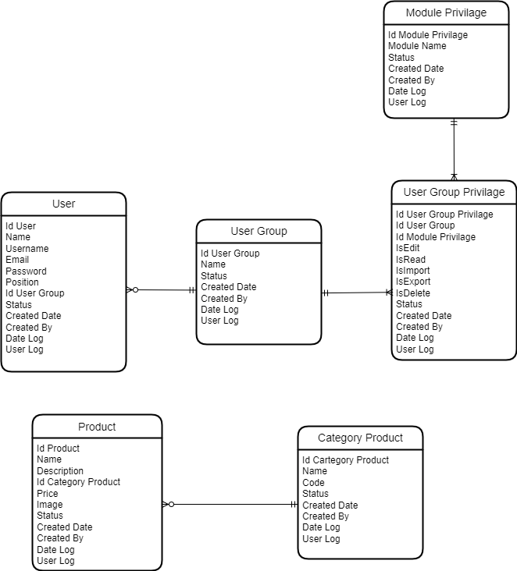

1. Data Manipulation Language (DML)

DML atau Data Manipulation Language merupakan perintah SQL yang berhubungan dengan manipulasi atau pengolahan data dalam table. Yang menggunakan DML :

* SELECT

SELECT * FROM MS_PRODUCT;

* INSERT

INSERT INTO MS_PRODUCT(ID_PRODUCT, ID_CATEGORY_PRODUCT, NAME, DESCRIPTION, PRICE, IMAGE_URL, STATUS, CREATED_DATE, CREATED_BY, DATE_LOG, USER_LOG) VALUES (“1”,”1”,”Majoo Lifestyle”,”Description”,”100000”,”assets/img/upload/product.png”,”1”,”2021-06-05 12:00:00”,”Admin”,”2021-06-05 12:00:00”,”Admin”)

* UPDATE

UPDATE MS_PRODUCT SET ID_CATEGORY_PRODUCT=’1’, NAME=’Majoo Pro’,DATE_LOG=”2021-06-05 12:00:00”,USER_LOG=”Admin” WHERE ID_PRODUCT = ‘1’

* DELETE

DELETE FROM MS_PRODUCT WHERE ID_PRODUCT = 1

1. Activity Diagram

Activity Diagram - Login

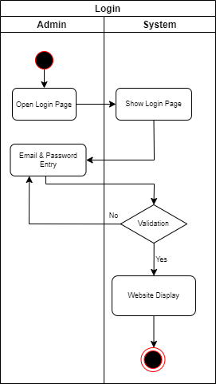

Activity Diagram - Create Product

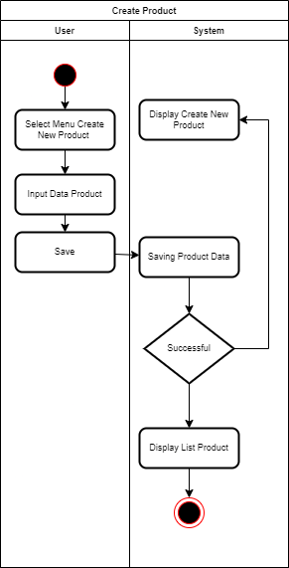

1. Use Case Diagram

